Lensbaby 2.0 Product Specs:

Brighter, Sharper, Faster selective focus photography

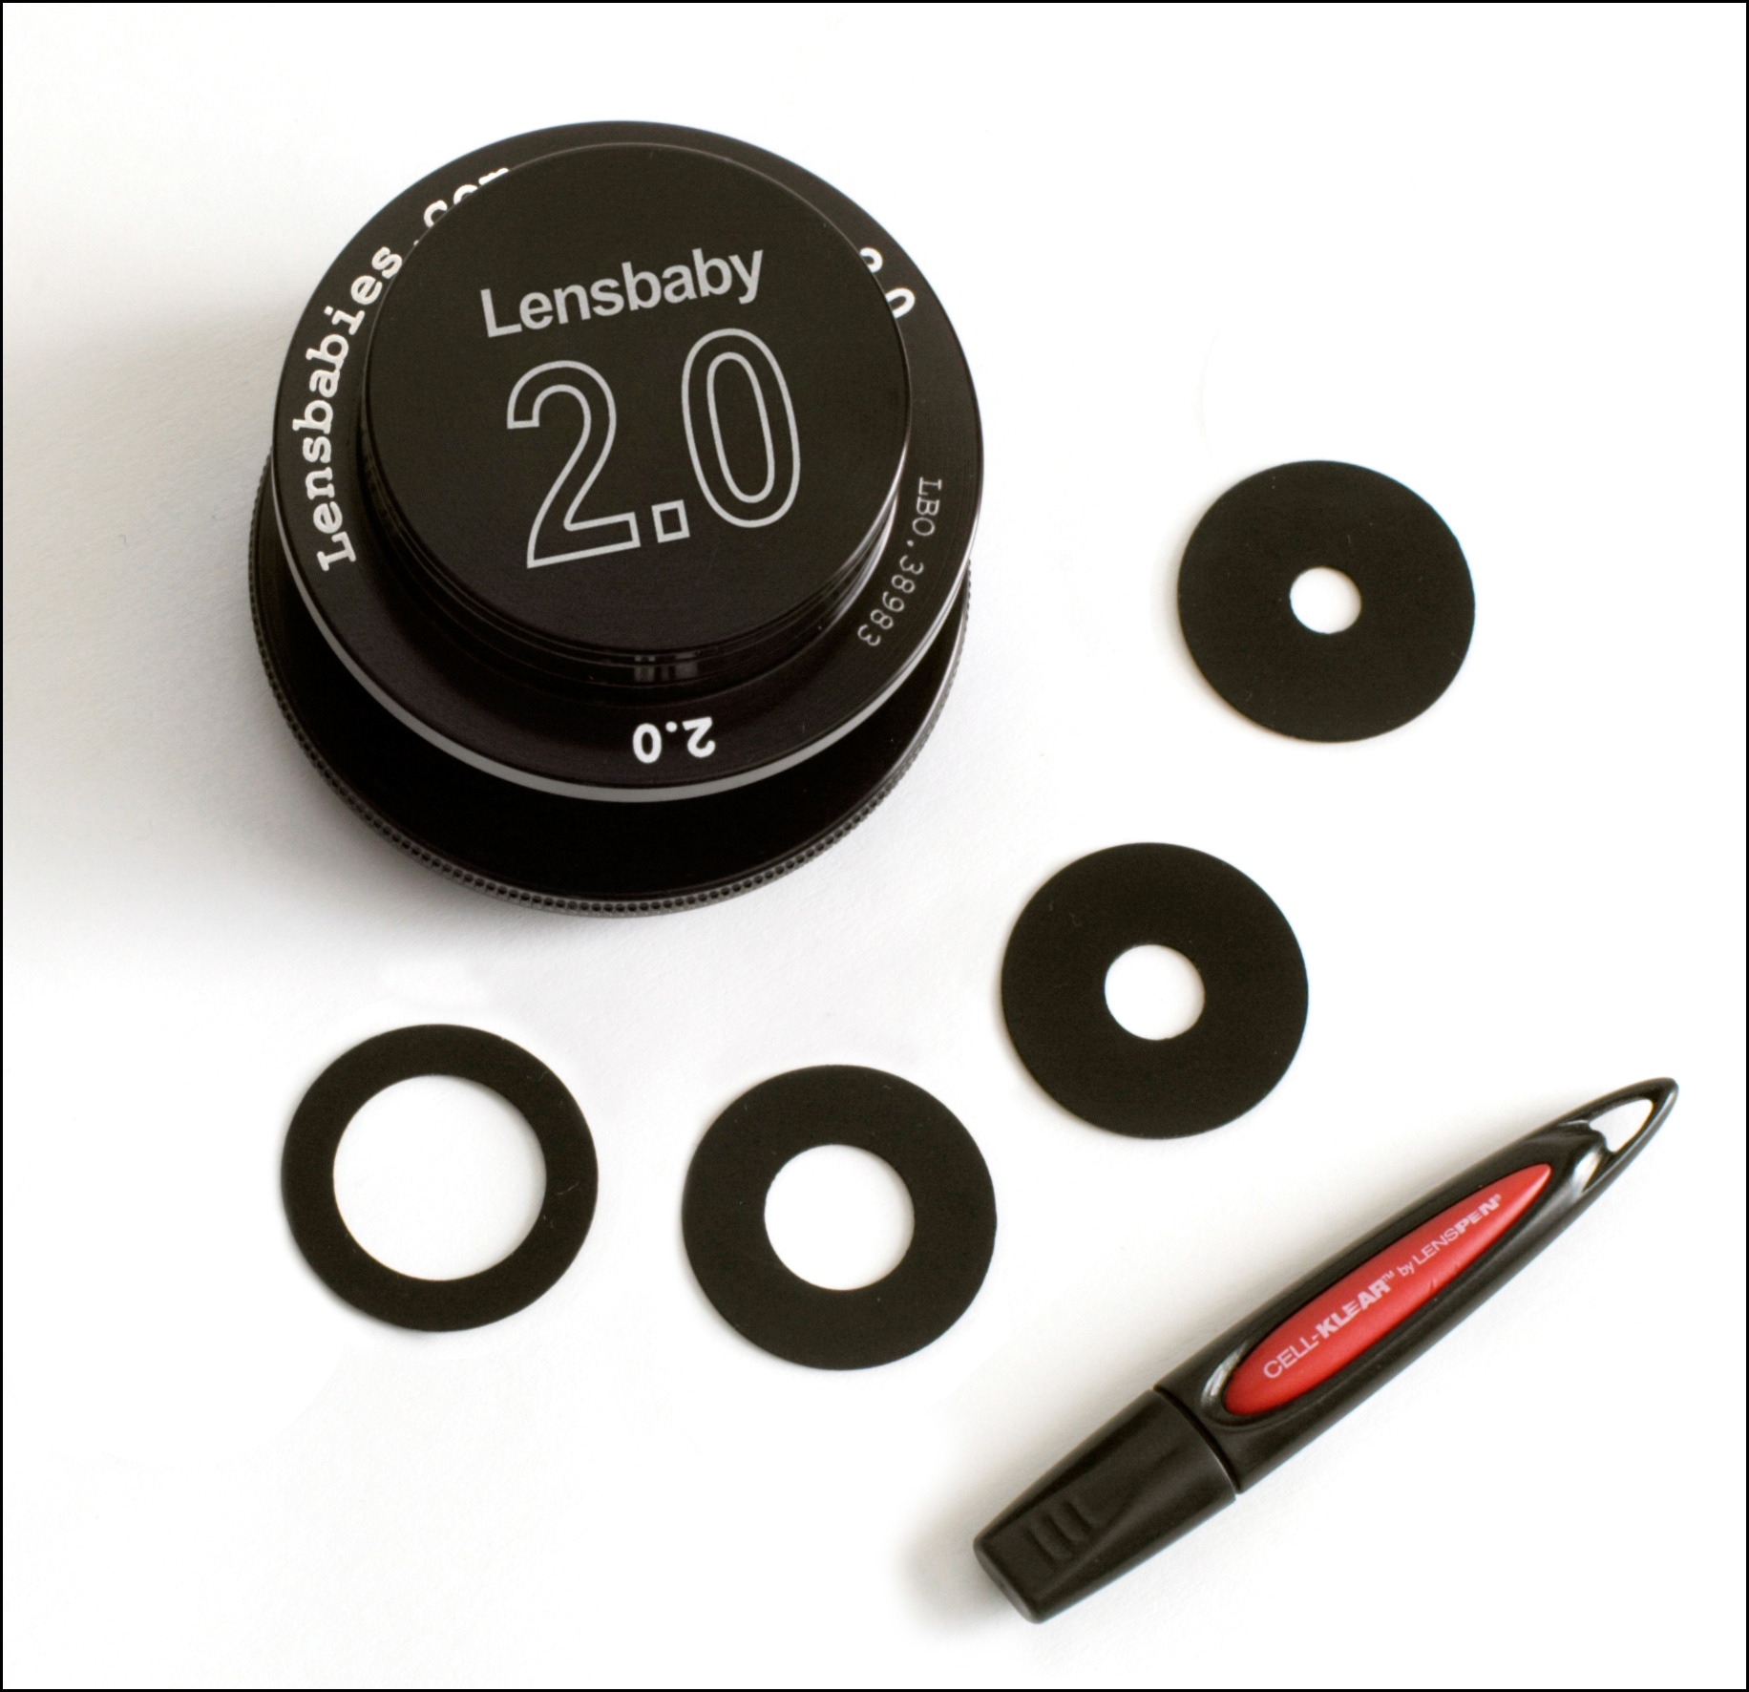

- Available in mounts for Canon EF, Nikon F, Pentax K/Samsung GX, Olympus E1/ Panasonic Lumix DMC, Minolta Maxxum/ Sony Alpha, Olympus OM, Canon FD, Leica R, Minolta Manual, Sigma, Contax/Yashica, and Screw mounts
- Focal Length: right around 50 mm
- Focus Type: Manual, fingertip, actually
- Optical element: coated, high refractive index, low dispersion optical glass doublet
- Aperture Type: Interchangeable levitating magnetic apertures
- Apertures: f2.0, f2.8, f4, f5.6, f8
- Nominal Focus: approximately 18 inches
- Maximum Focus: infinity and beyond
- Minimum Focus: approximately 10 inches (achieved by pushing on the back of the focusing collar)
- Size: 2.25" high x 2.5" wide
- Weight: ~3.6 oz.
- Manufacturer Suggested Retail Price: $150

The Original Lensbaby and Lensbaby 2.0 Compared
Lensbaby 2.0 is brighter, sharper, and faster

 | Lensbaby 2.0 | The Original Lensbaby
Aperture settings | f/2.0, f/2.8. f/4.0, f/5.6, f/8.0 | f/2.8. f/4.0, f/5.6, f/8.0
Optical glass element | Coated, high refractive index, low dispersion optical glass doublet | Uncoated single optical glass element
Aperture system | Levitating magnetically receptive aperture discs that float above the optic | Aperture discs held in place with a friction fit rubber gasket

Lensbaby 2.0 aperture system

Lensbaby 2.0 utilizes a system of levitating magnetically receptive discs that float above the optic. When the aperture discs are dropped into the Lensbaby, they snap into place, held just above the optic by magnetic attraction from the three shielded rare earth magnets embedded in the optics cup. Removal is also easy, and Lensbabies provides a complimentary Cell-Klear™ Lenspen® that the photographer can insert through the center hole in the aperture disk to lift it out.

Contact:

Sam Pardue Steven I. Rosenbaum or Leigh Nofi
CEO, Co-Founder Lensbabies, LLC S.I.R. Marketing Communications, Inc.
503-516-5569 631-757-5665
sam@lensbabies.com sir@sironline.com

